

INSTALLING WAZUH AND

WAZUH AGENTS

**STEP-BY-STEP GUIDE**

1. Dowloading .OVA file to install Wazuh in Window Operating System

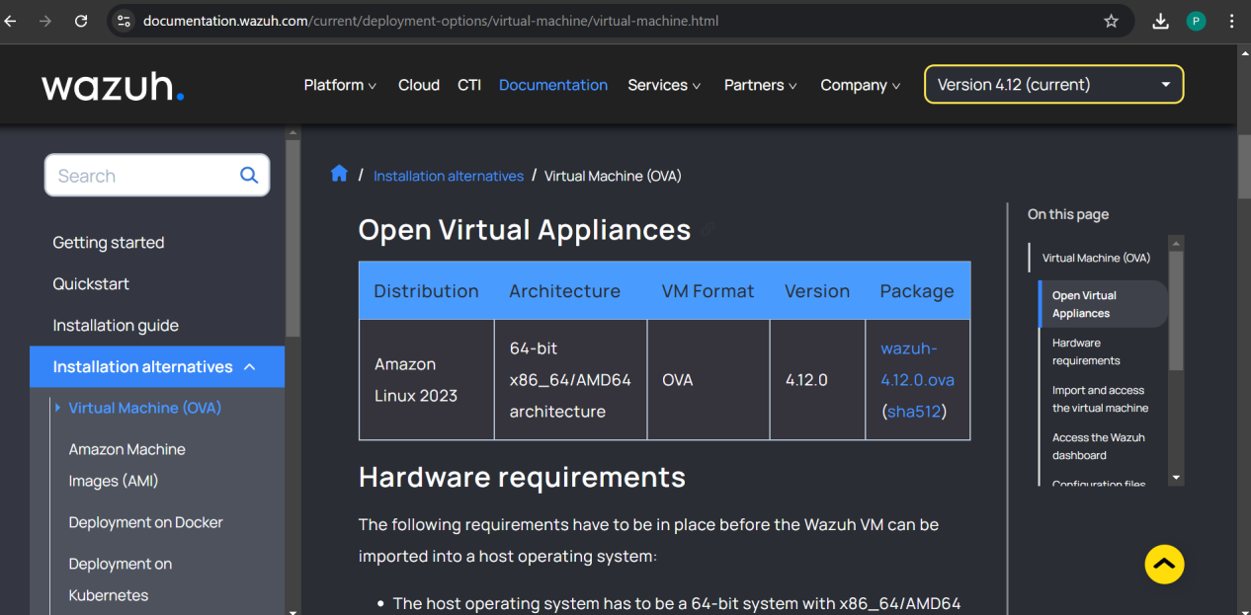

The Packages List tells us about the Version File format and Distribution of the Wazuh Current version.

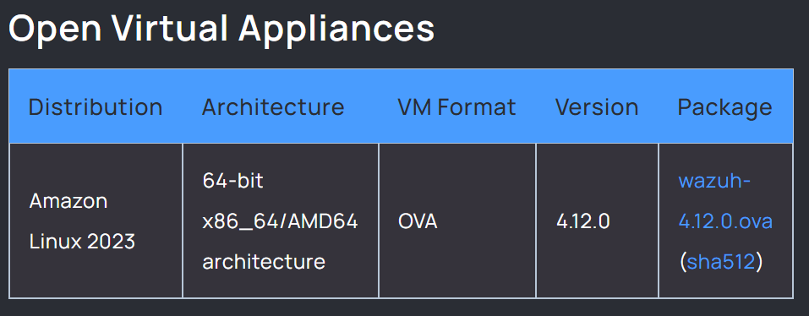

Importing the Wazuh OVA file in Virtual Box.

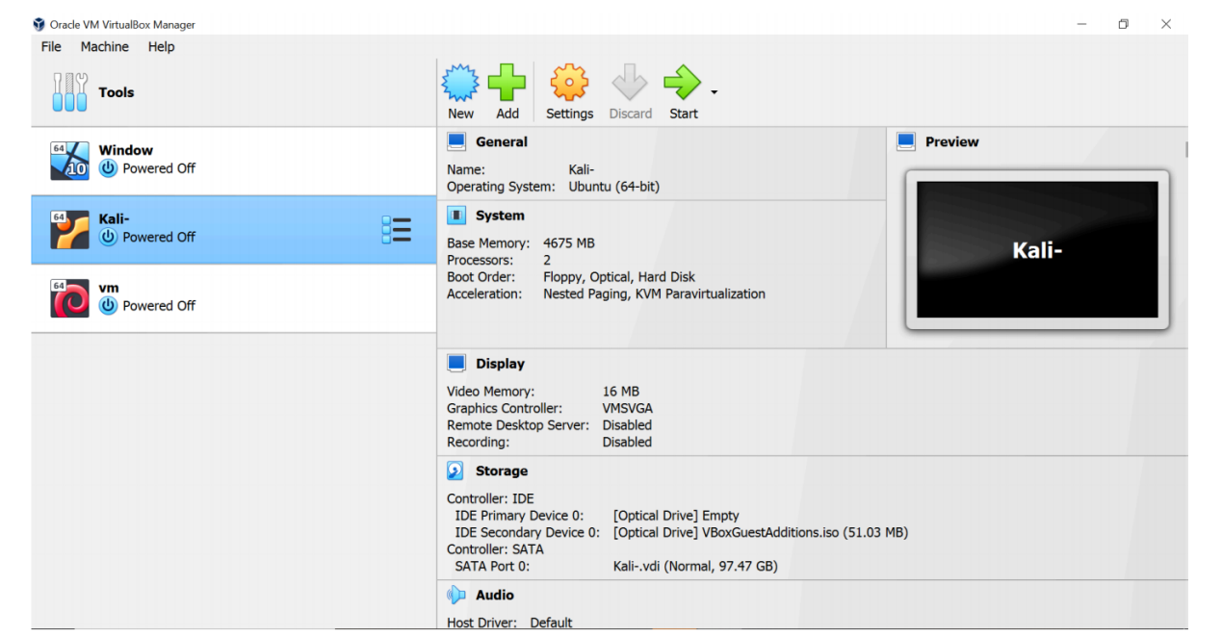

After opening the Virtual Box go to File> Then Import Appliances.

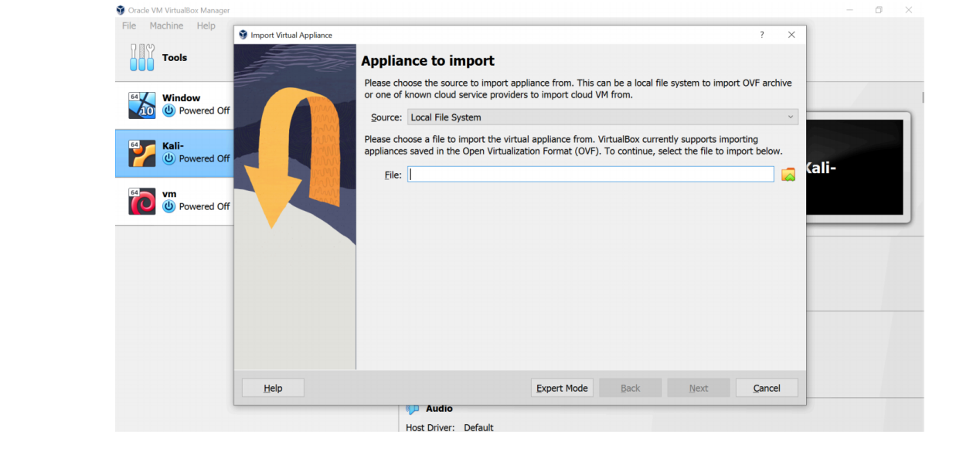

Now Select the Ova Wazuh File.

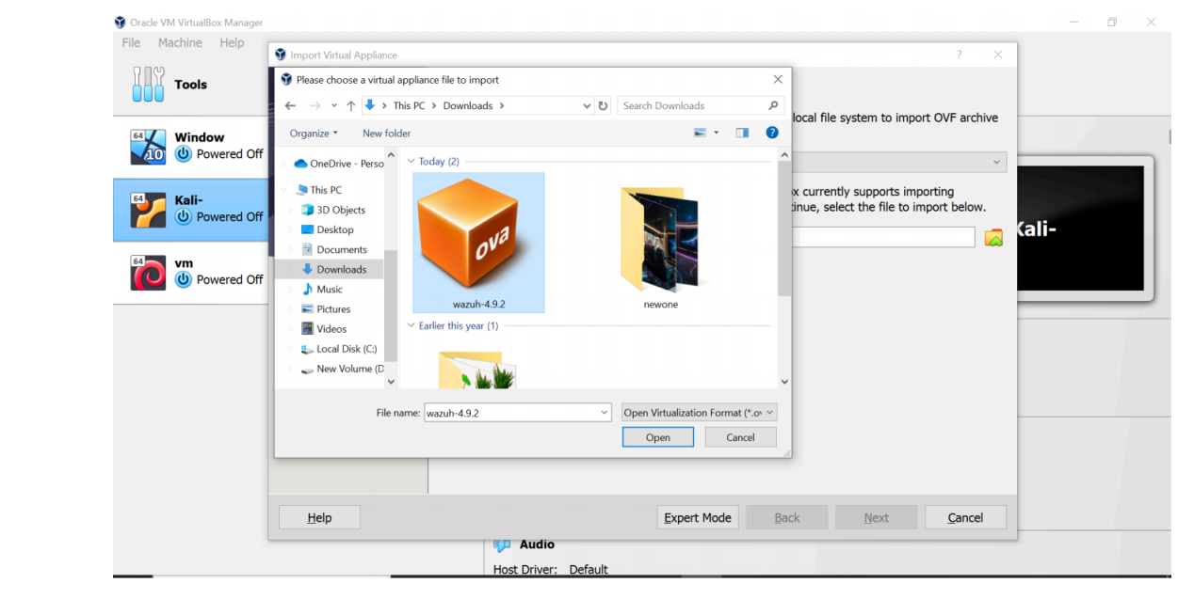

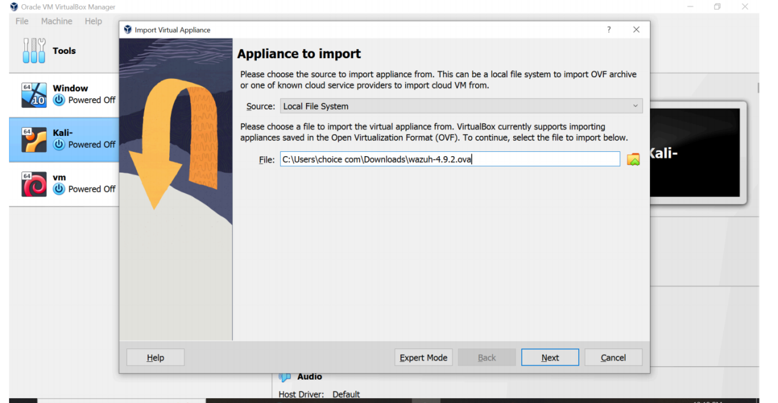

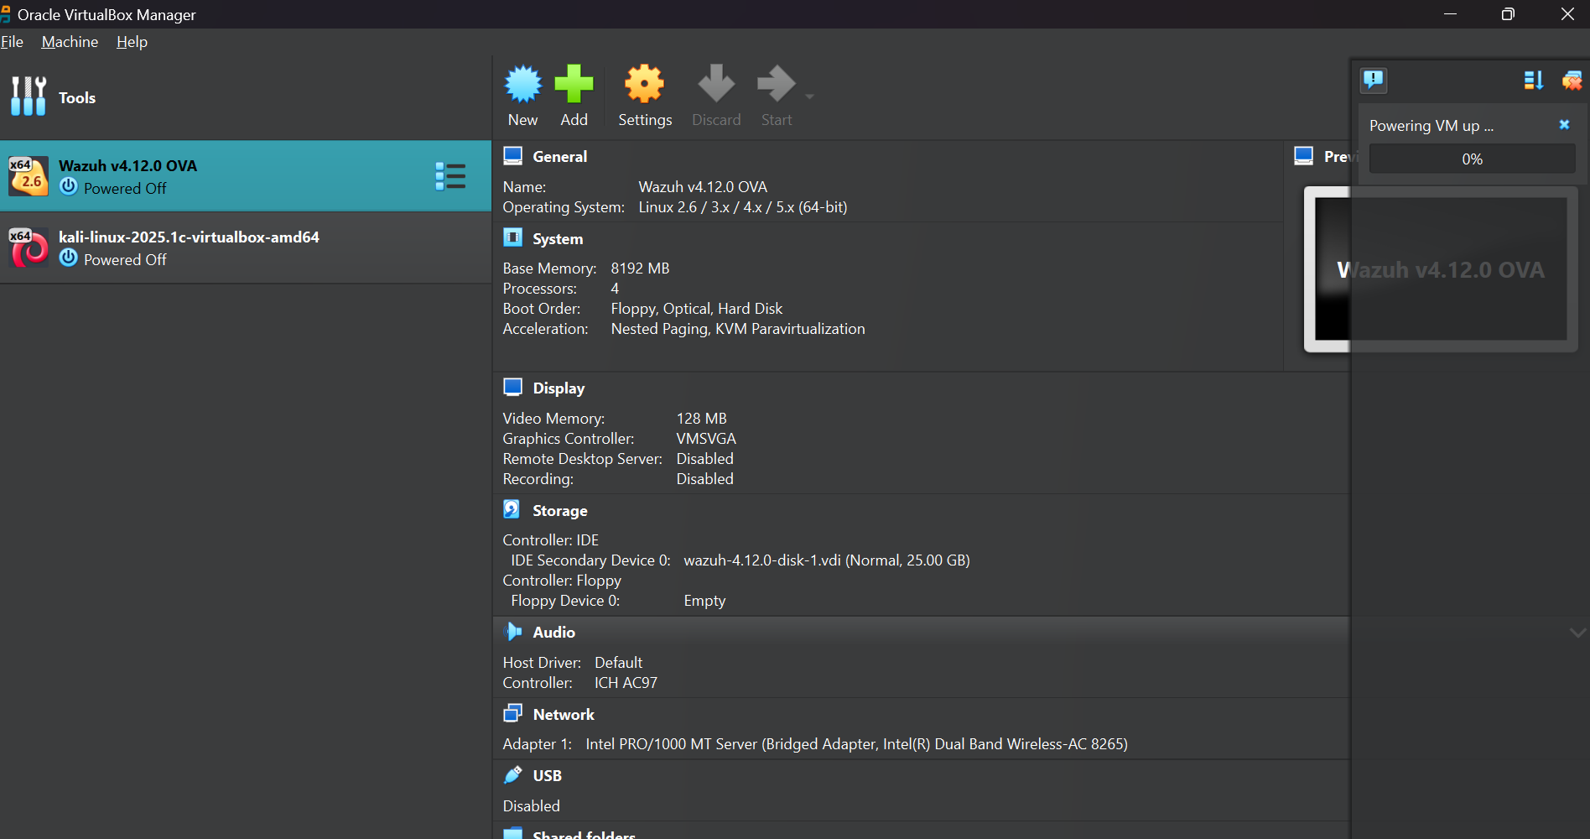

Wazuh File imported successfully.

1. Changing the Network Setting to “Host-only-Adapter”

Select the Wazuh machine and then Click on the Setting icon.

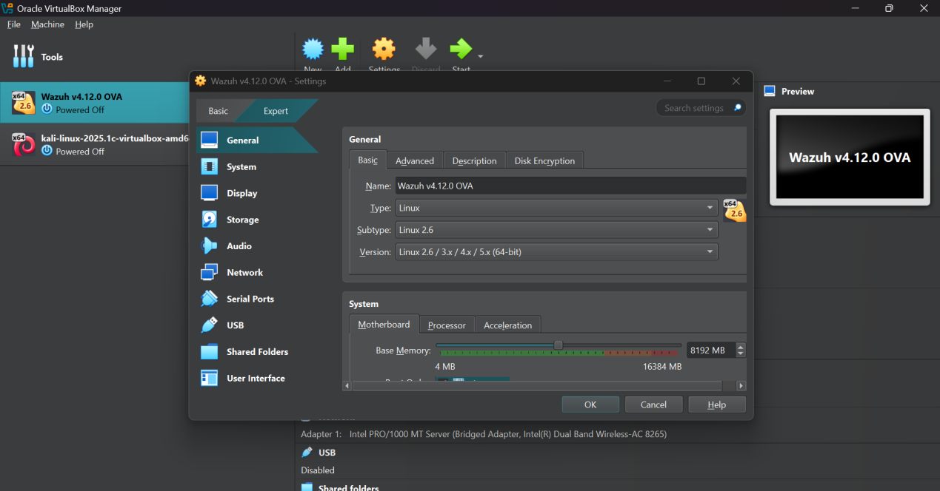

Now go to network tab and change the adapter.

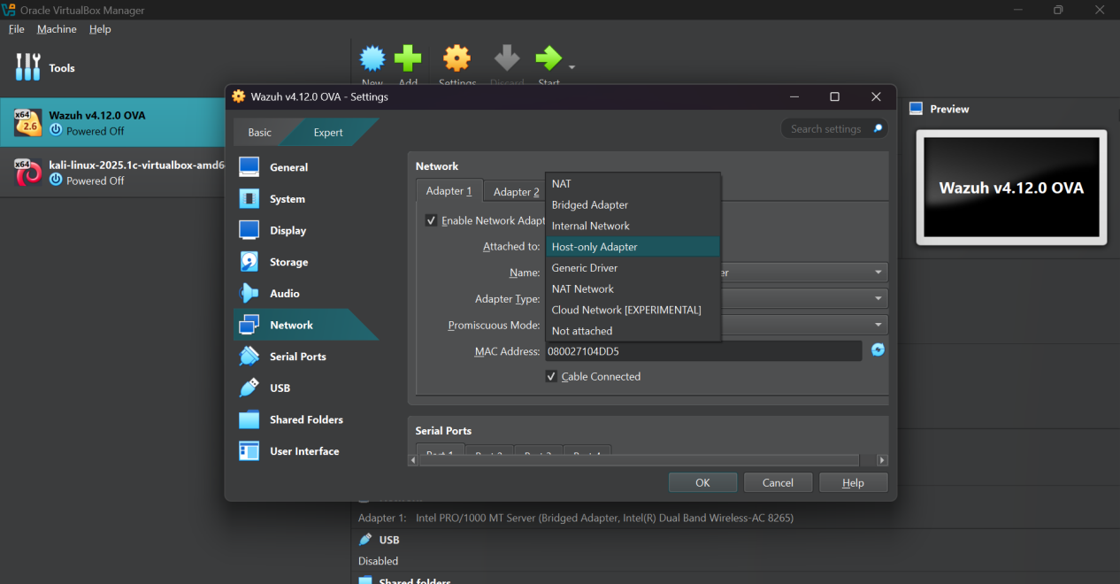

Select Host Only adapter then Hit OK.

1. Start the machine

Click on the start button to start the wazuh. After stating Enter the Username and Password

Username: wazuh-user

Password: wazuh

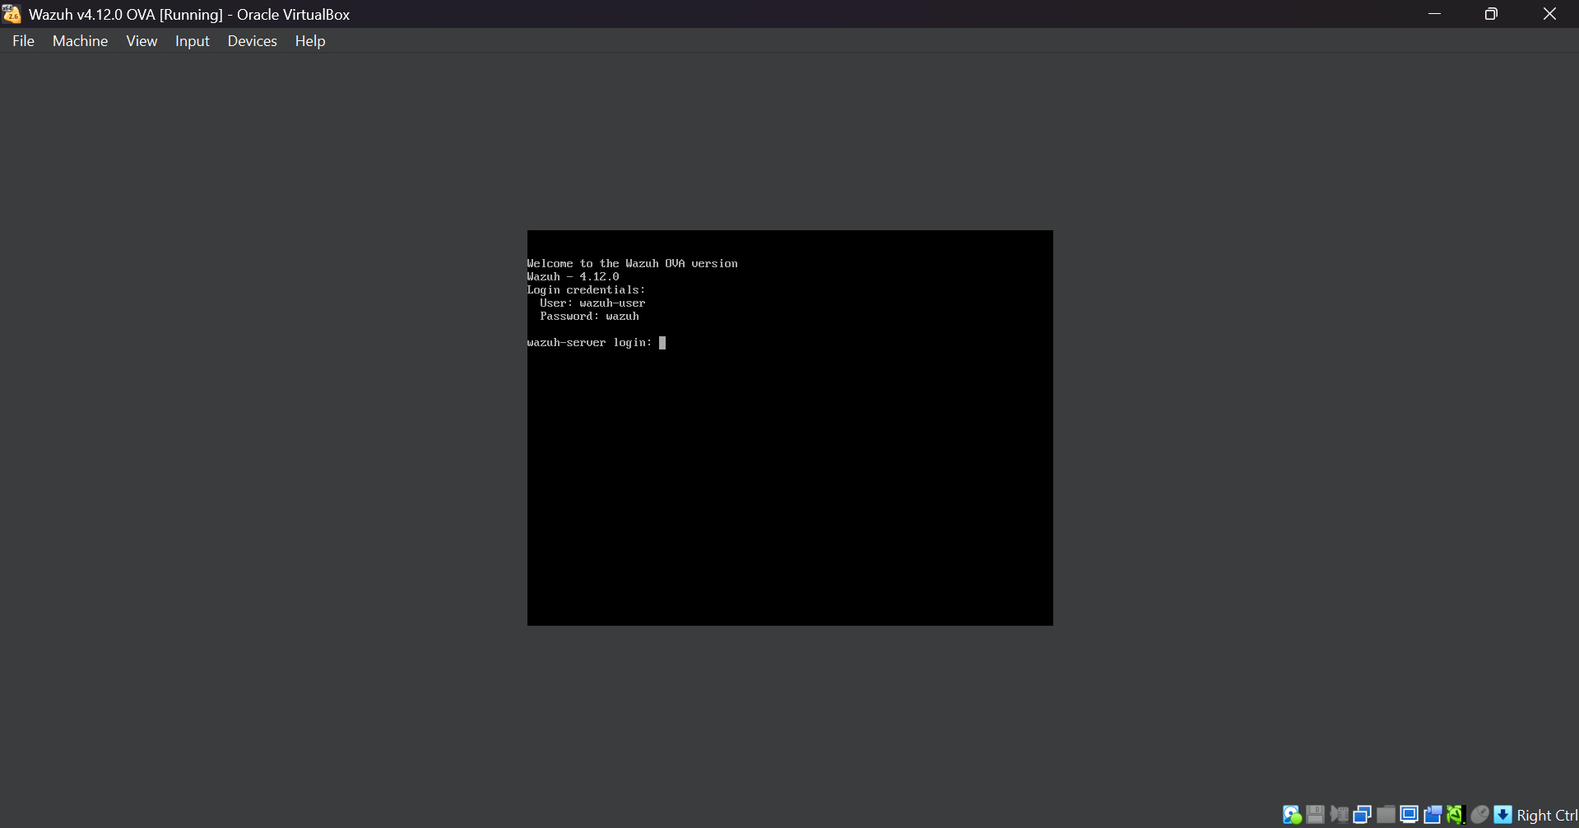

Enter Username and Password then press Enter. After login write these commands:

sudo systemctl start wazuh-dashboard  
sudo systemctl start wazuh-indexer

After command write “IP a” to check IP Address of your Wazuh machine.

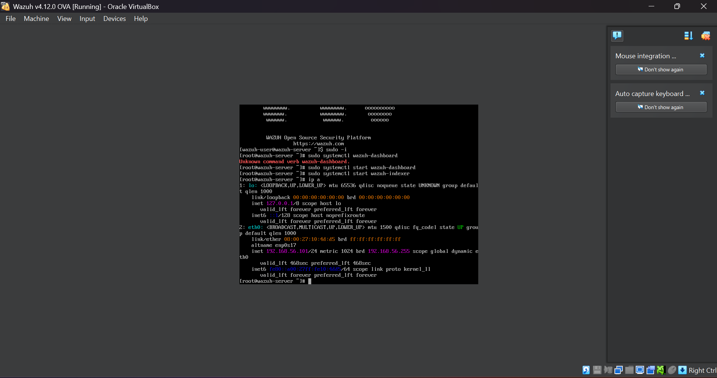

My wazuh IP address is **192.168.56.101**

4-Accessing Wazuh Dashboard

Type Wazuh IP in your browser to access the Wazuh Dashboard.

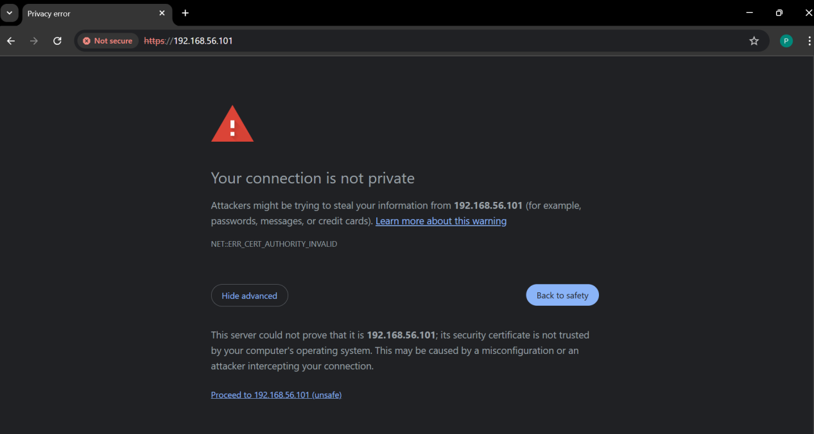

Click on “advanced” then click on proceed to continue to the wazuh.

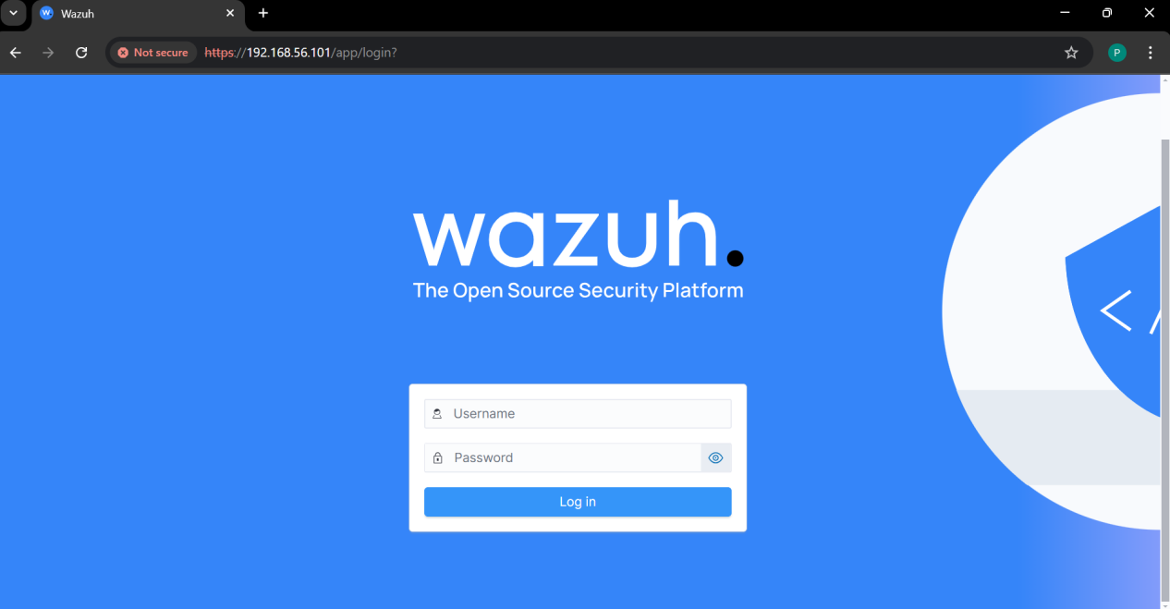

To login to wazuh Dashboard Enter Username and password:

Username: **admin**

Password: **admin.**

1. Navigating the Dashboard

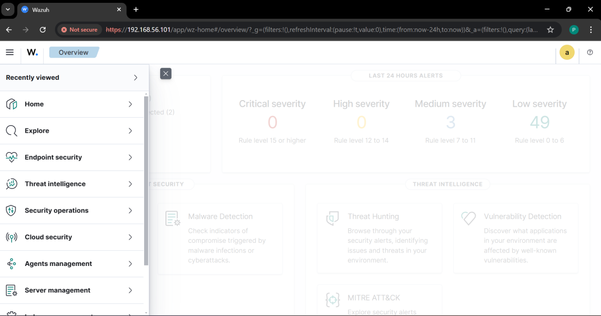

1. Deploying Wazuh Agent

**WINDOWS:**

Go to agent Summary

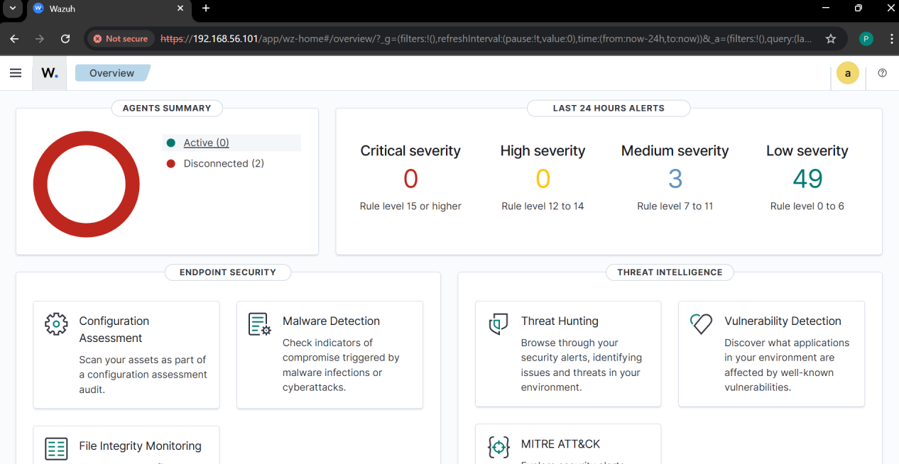

Click on “Deploy a new Agent”

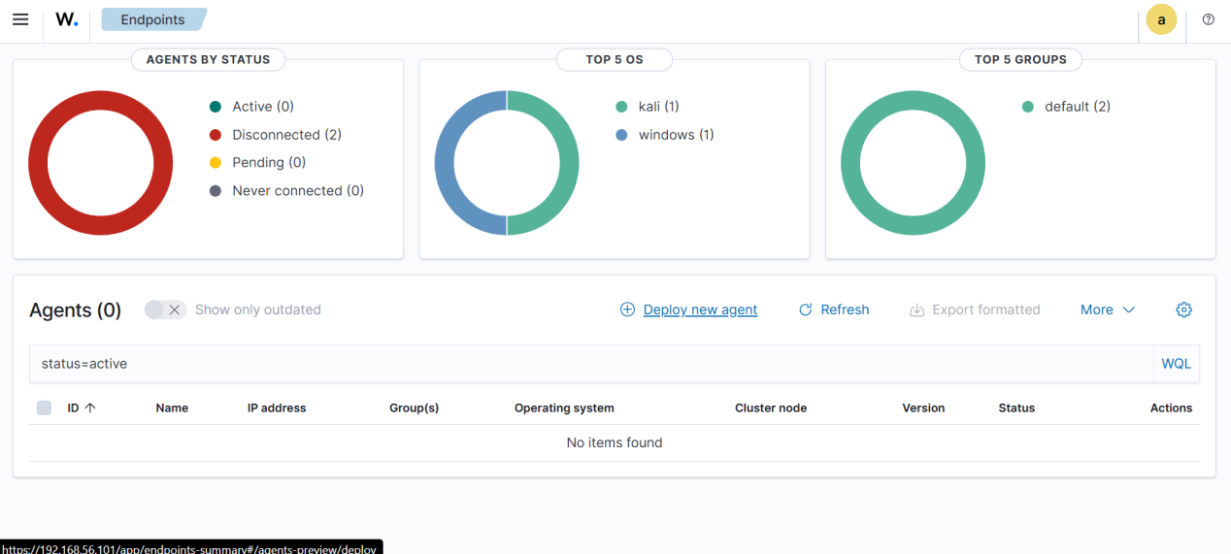

Select Windows.

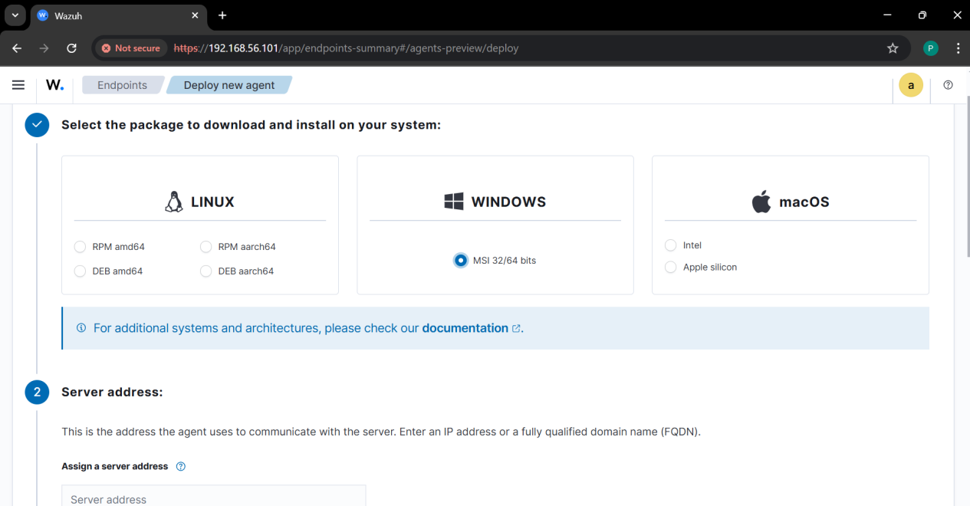

Add IP address that is server’s IP address. And also assign a agent name.

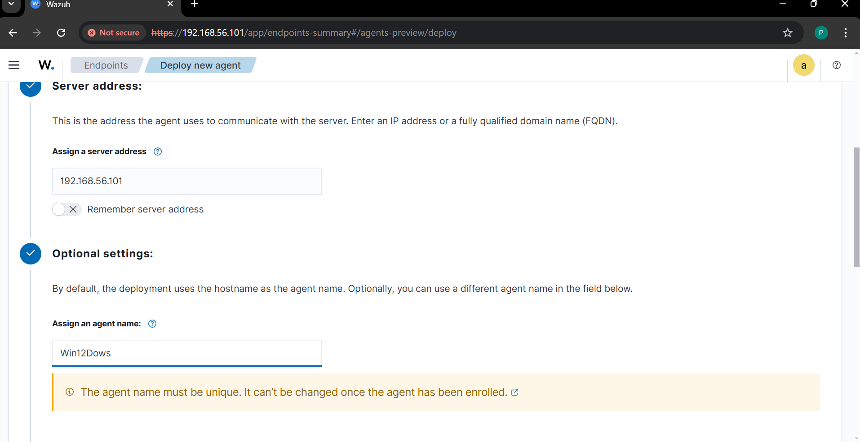

Run the given Command in Powershell administer.

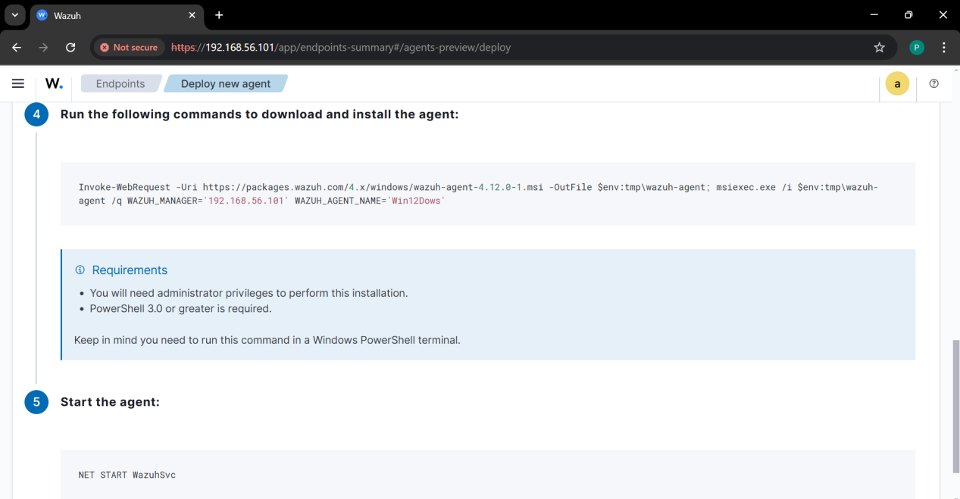

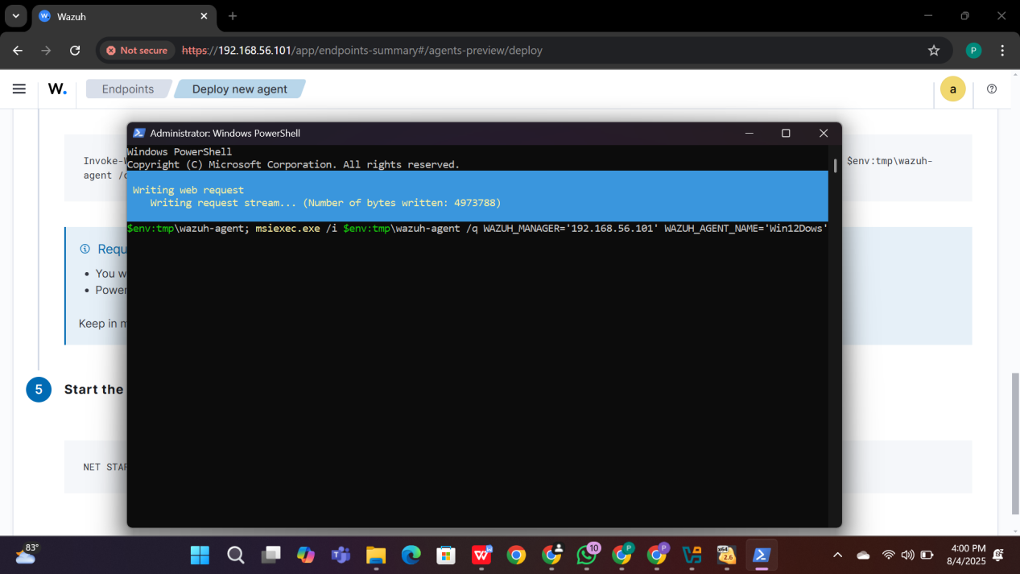

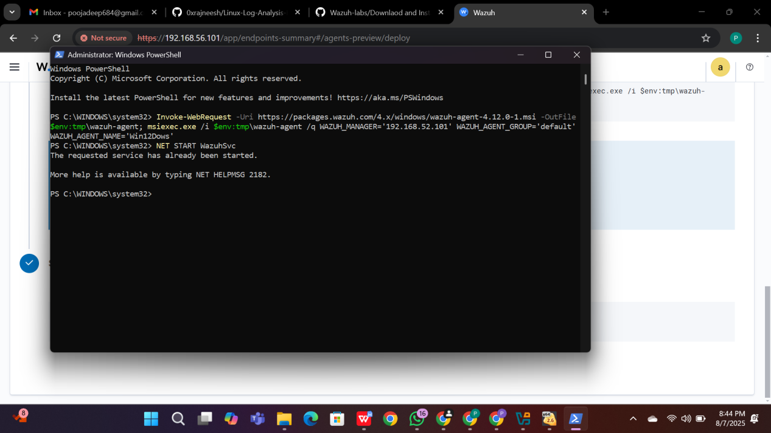

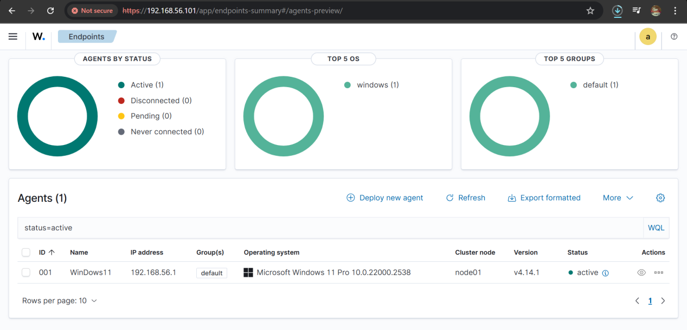

**LINUX:**

Add wazuh repository:

* Open Terminal
* Add wazuh repository by running:

Run these commands:

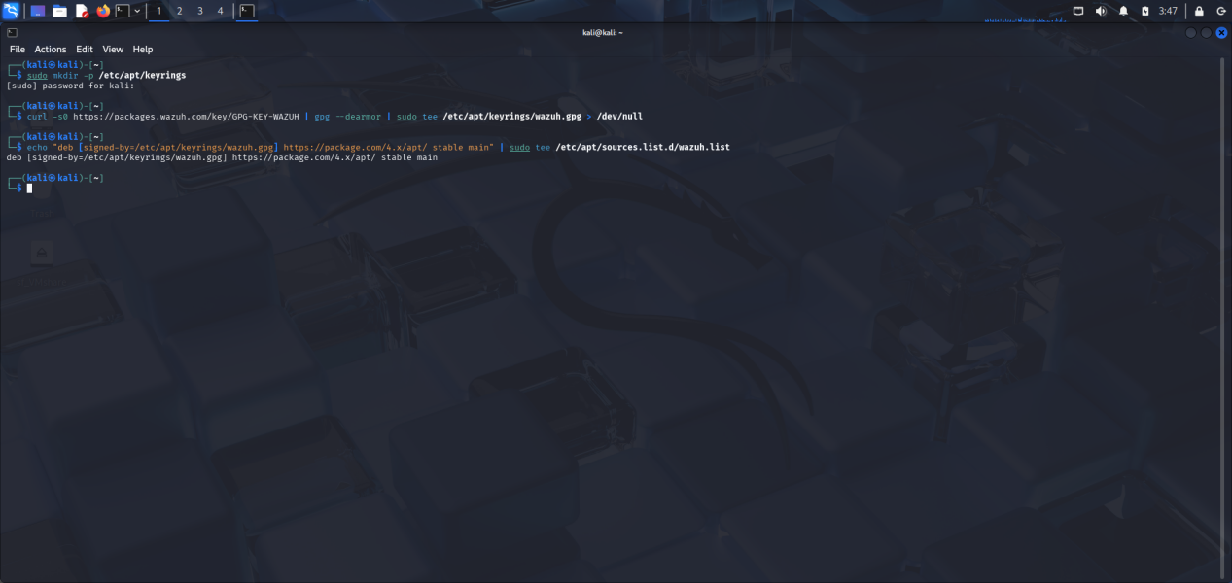

Update your package:

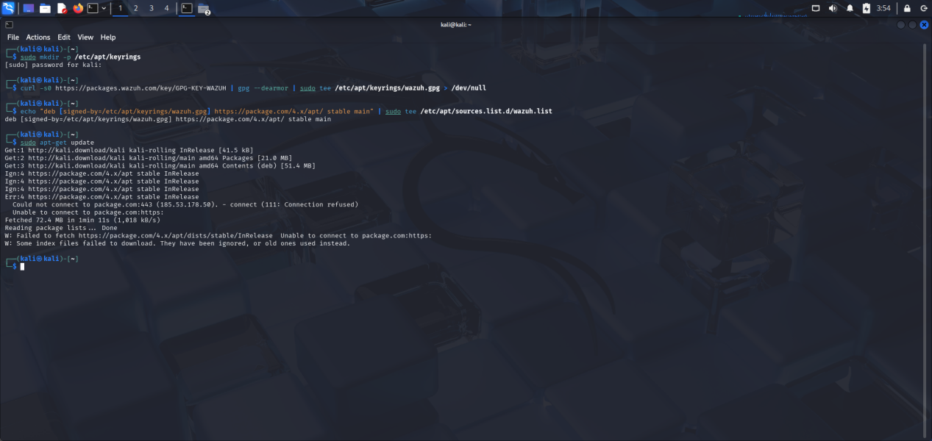

Install Wazuh-agent:

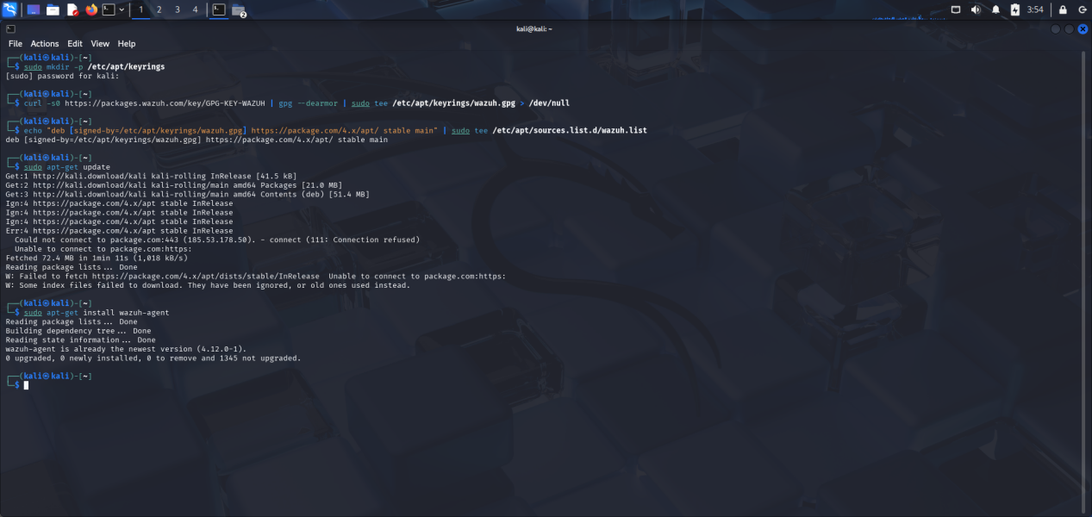

Configure the wazuh-agent

* Open file manager and navigate to /var/ossec/etc/ossec.conf
* Find <address> tag and set it to your wazuh manager’s IP address.

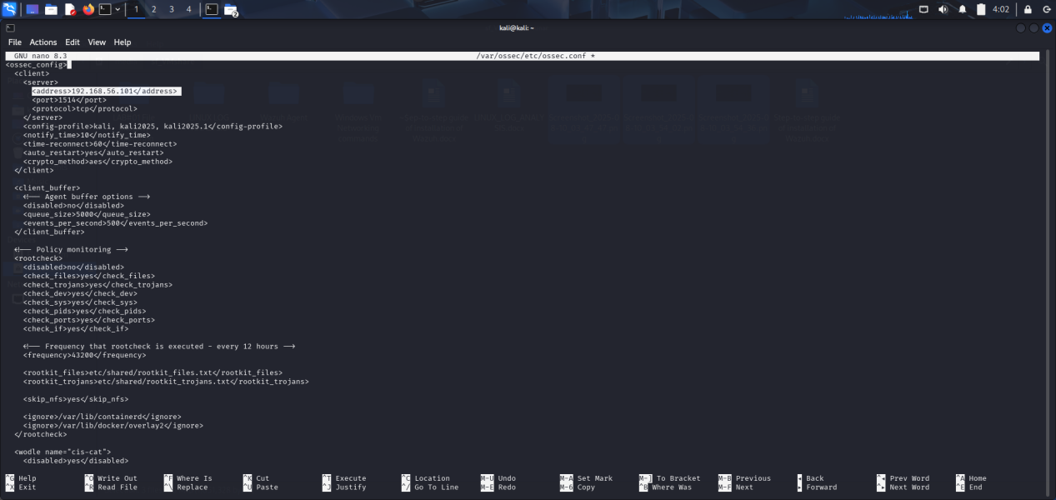

After adding IP save it and start the agent.

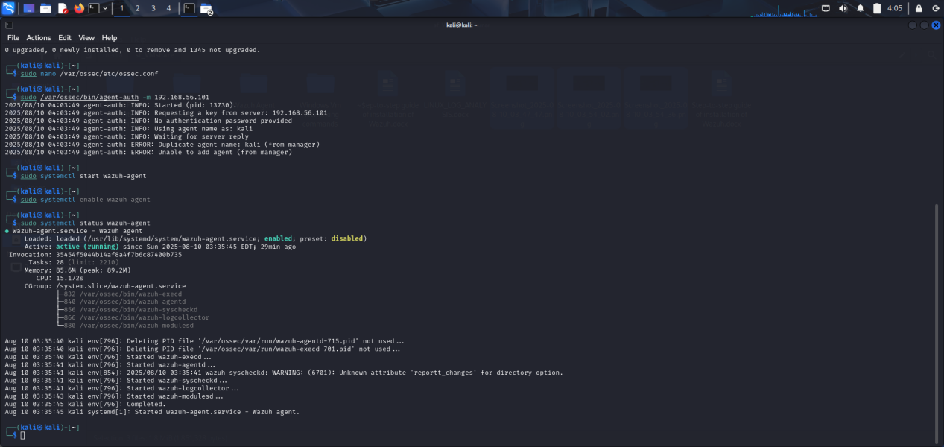

1. Verification

**Agent Installed Successfully**

